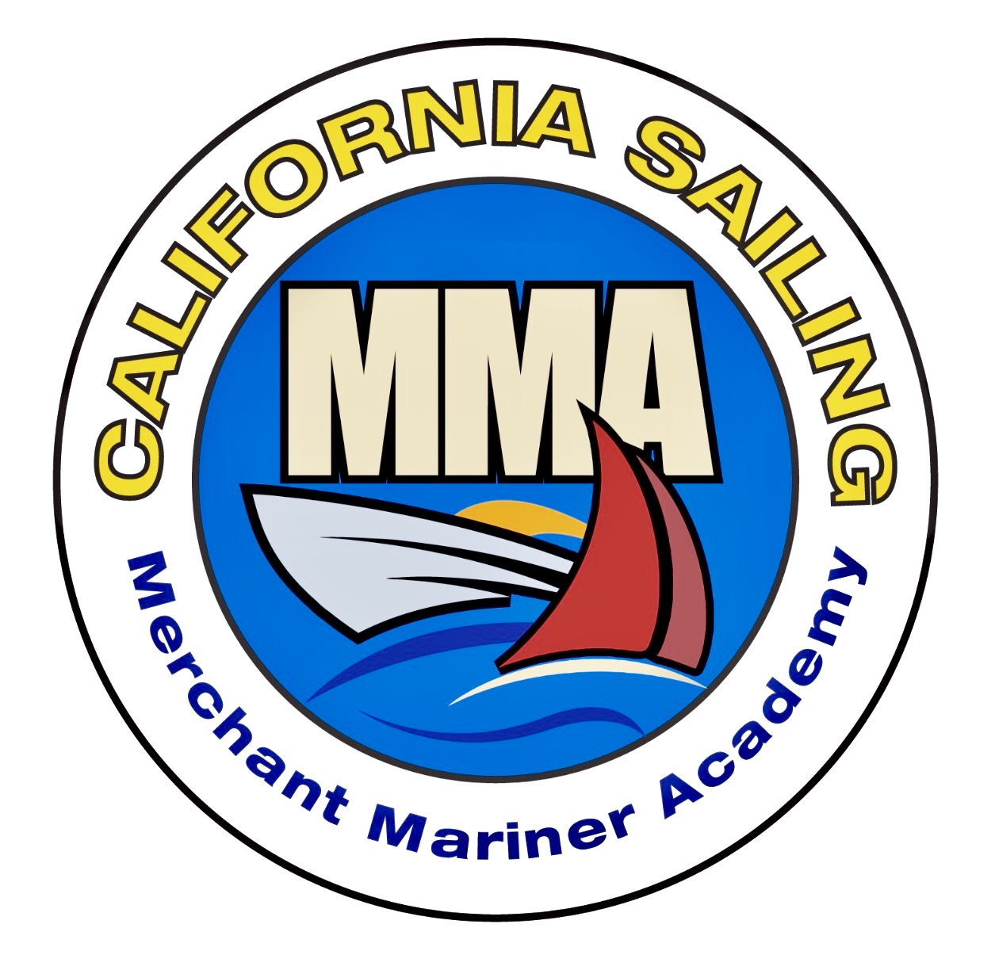**California Sailing**

***Merchant Mariner* *Academy***

***California Sailing Academy LLC***

***Captain Wendy Sarnoff***

## *12043 Havelock Ave.*

***Culver City, CA 90230***

[Integrtd1@aol.com](mailto:Integrtd1@aol.com)

CSMMA.org

**CHAPTERS 1-10 = Day 1 REVIEW QUIZ**

We want you to have the best learning experience during your Day 1 and Day 2, Safety-at-Sea Seminar. We therefore ask that you Pre-Read Chapters 1-10 well before Day 1 and Pre-Read Chapters 11-15, prior to Day 2.

The hope is that you find the review quiz helpful and informative. See you at Seminar!

Chapter 1

1) The distinction between Federal Statutes and Racing Rules is that all vessels Must provide assistance and give all possible help to any person or vessel in danger. T/F

2) Two major obligations when responding to a distress call are a) Monitor Radio Communications b) Provide food, water and shelter c) Provide medical assistance d) Log accurately all radio communications e) Answers A and D

3) Which is not a consideration when providing assistance, a) Your distance to the emergency b) the health, safety and sea-worthiness of your vessel and crew c) the liability involved d) Skills and equipment that you have on-board e) can you get there in a time

4) There are at least 9 stages of a typical rescue T/F

5) Which of the following would not be considered a type of sailing assistance a) providing Shelter, food, water or spare parts b) Providing skills, radio relays or medical assistance c) recovering crew overboard assistance d) providing crew members e) Fixing a flat tire on the road

6) In considering how to maneuver near a disabled vessel which of the following could endanger your vessel and crew a) Standing by, while Heave-to b) Transferring materials using inflatables, Dingys or other buoyant devices c) Passing a line, heaving line or Monkey's fist d) Hip tying with many fenders between both boats e) Using fenders, life Slings, PFDs or other devices to float lines or materials downwind.

7) Towing a vessel needing assistance is always legally required T/F

Chapter 2

1) Rule Number 1 STAY ON THE BOAT T/F

2) Most Sailing related deaths are due to not wearing a life jacket and drowning T/F

3) Your life jacket will not a) Bring you back to the surface, b) maintain you in an upright attitude c) reduce some aspects of hypothermia d) Perhaps help you survive after losing consciousness e) Hold your body strapped together in the H.E.L.P position

4) There are Five Classifications of life jackets in our current North American system. T/F

5) The future level of life jacket classification is based on levels of buoyancy T/F

6) Inflating devices come in many different forms and price ranges. All are the same T/F

7) Auto-inflate life jackets often have inflation difficulties and do not deploy properly T/F

8) Which Acronym does not match a) SER = safety equipment requirements b) Offshore Special Regulations = OSR c) International Organization for Standardization (of life jackets) = ISO

d) Ride Up Protection Systems = RUPS e) Off shore Real Rules for Racing = ORRR

9) It is important to inspect and maintain your lifejacket and attached equipment T/F

10 Harnesses and tethers are used to keep us attached to our vessel T/F

11) Jacklines form a rope hammock for us to flake our mainsails in when lowering the sail T/F

12) New advanced tethers have a single leg, or one flat strip T/F

13) Things you should not add to your lifejacket might include a) a salt water activated strobe light b) Lume-ons c) Personal locater beacons or AIS beacons d) Whistle e) Salt Water Activated Flare

14) A lifejacket can only save you if you are wearing it! T/F

Chapter 3

14) Pre-departure drills are a requirement in order to participate in many offshore races. T/F

15) As a responsible crew member, you inspect your safety gear know the locations and how to use vessel safety and locater equipment T/F

16) You the vessel owner. You inspect and maintain these boat systems: tankage, pumps, electrical, batteries/electronics/lighting, drag systems, gaskets/hatches, sanitation devices, refrigeration systems, propane systems, and fire suppression systems. T/F

17) You don't have to label every item of floating gear. T/F

18) Two sets of navigation lights with independent power sources are required by the WSO. T/F

19)EPIRB stands for emergency personal iridium racon beacon and has a 20-year battery. T/F

20) Which item does not need regular servicing? a) life raft b) Dan buoy c) life jackets d) fire extinguishers e) all of the above and all safety equipment needs to be inspected/serviced regularly

21) As a responsible crew member, I know how to deploy and use the following: PLB's, EPIRB's, Life Slings, Dan Buoys, Mom Packs, MOB equipment (throw rings), signaling devices, radio equipment, flares, harnesses and tethers and throw ropes. T/F

Chapter 4

22) Fire is the second most common reason for a crew to abandon ship. T/F

23) Which has the highest probability of creating a fire on-board a boat? A) Diesel fuel b) Fuel leaks c) Engine/transmission overheating d) Electrical fires e) Galley fires

24) A, B, C, D and K are classes of fires T/F

25) APASS and FIRE are useful acronyms for extinguishing fires T/F

Chapter 5

26) The USCG acronym for a person overboard is a) MOB b) WOB c) COB d) PIW e) POB

27) As a responsible crew member, you sail smart by: using a double tether, wearing new/clean deck shoes, using a fitted life jacket/harness and tether, clipping on to solid objects that handle a moving shock load, crawl if needed, walk on the high side and use a jackline (pulling up) as you move. T/F

28) All members of the crew have practiced PIW drills using the Seven step Universal Man Overboard Recovery Response, on your vessel T/F

29) Every person on-board has practiced and can drive the following PIW boat handling maneuvers: 1) Heave to b) Circling without trimming c) Quick-stop d) Figure 8 and e) Returning under power T/F

30) The sails you are flying Spinnakers, ASOS, Poled-out jibs, bloopers etc. do not require extra consideration or attention during a PIW drill and recovery T/F

31) Which point of sail is the best approach to a PIW a) Dead Down Wind b) Broad Reach c) Beam Reach d) close hauled e) close reach with the PIW to leeward of the vessel

32) As a responsible crew member, you know how to and have practiced getting a person back on board using the following: 1) life-sling 2) boarding ladder (amidships) 3) brute force 4) elevator and 5) climbing ladder equipment

33) As a PIW, I have multiple pieces of equipment on/in my life jacket that will help me be 1) Heard, 2) SEEN 3) found 4) located and 5) retrieved T/F

Chapter 6

34) Hypothermia is a type of medical syringe used by a doctor to give shots T/F

35) Removing clothing as a PIW causes increased loss due to a) conduction b) convection c) radiation d) evaporation

36) There are four increasing levels of hypothermia T/F

37) the 1-10-1 principle and your three goals, helps you, the PIW remember the best sequence to being rescued and surviving

38) These are all survival factors 1) ability to swim 2) Sea State 3) Water Temperature 4) Physical Characteristics 5) In-the-Water behaviors. T/F

39). I am a responsible crew member who knows how to assess and care for a person with hypothermia. T/F

40) As a responsible crew member, I know the best medical practices for drowning (recovery and care), CPR and trauma T/F

41) A USCG helicopter is always available and at the ready to rescue you no matter where you are on the ocean. T/F

Chapter 7

42) I choose to operate at my optimal physical and mental health while sailing. T/F

43) Due to the Hippa Act, I choose my information regarding Personal medical history, allergies, current medications, an EKG, immunizations and my doctor's information to remain private. I can bring my information in a sealed envelope so that it remains on-board for my personal safety. T/F

44) Upper respiratory and GI infections can spread easily in the enclosed spaces on a boat. T/F

45) Unsanitary hand washing and food contamination can cause all of the following except a) nausea/vomiting b) dehydration c) GI tract infections/fever d) stomach cramps e) sunburn

46) Calorie depletion and low blood sugar can compromise sailing performance T/F

47) Crew members are responsible to mitigate sea sickness so as not to compromise the safety of the crew and vessel. T/F

48) Emergency medical responses (sprains, strains, breaks, burns, wounds and contusions) require knowledge and training with the medical equipment and supplies on-board T/F

49) Burns and wounds may become infected and require monitoring and additional treatment T/F

50) Sun burns may blister and cause infection T/F

51) Melanoma refer to A, B, C, D, E, is a new flavor of Ice Cream. T/F

Chapter 7 continued

52) Head Trauma, Heart Attack, Shock, Anaphylactic Shock (extreme allergic reaction), depending on the severity, require additional medical/trauma care and medications. As a responsible crew member, I would benefit my team if I had WEMT or WFR training. T/F

Chapter 8

53) I understand and know how to respond to weather on the Beaufort Scale T/F

54) Which is not a global weather zone? a) ITCZ b) Tradewinds c) Horse Latitudes d) Variable Westerlies e) Polar Bear fronts which are only found at the North pole

55) In reading weather maps know your Lows, how they rotate, what wind speed and direction arrows look like and how they show counterclockwise (NH) rotation. The rounded bumps always show the LOW. T/F

56) Squalls and Thunderstorms always last for three to four days, non-stop! T/F

57) The European weather model is often the best forecasting model available. T/F

58) NOAA has information for both Offshore and Coastal water forecast areas. T/F

59) Wave Dynamics can be affected by storms far away at sea. T/F

60) Currents can be affected by water temperature and depth T/F

61) A Lee shore is always on the leeward side of the vessel T/F

Chapter 9

62) Remember, you don't ever HAVE TO RACE! T/F

63) Harnesses, tethers, Life jackets, Foul weather clothing, proper foul weather shoes, PLB, crotch strap/thigh straps, gloves, are all required equipment discussed in Chapter 2. T/F

64) Which is out of order? a) Drop the traveler b) Rig jack lines c) Hoist storm Trysails d) Deploy the drogue e) Begin reefing

64) Which of these is out of order? a) Prepare easily consumed foods b) Secure/Stow everything below c) Prepare the galley for rough weather d) Be ready to adjust the "plan" e) Stow the heavy gear on deck at the very last to balance when you are in the storm

65) I understand the concepts of and use of the following equipment: Sea State, Heavy Weather Techniques, Heave-To, Fore-Reaching, Lying Ahull, towing a Drogue (or Warps) and how to deploy Storm Sails T/F

Chapter 10

66) Like reefing, storm sails should be bent on well before you need them. T/F

67) Depowering your sailboat means slowing down the engine RPM's T/F

68) If you are in a leeward slip (or at anchor) a good thing to do would be to practice your reefing protocols to know how your equipment and how it works. T/F

69) Offshore Sailing Rules are clear in their standards/construction and visibility regarding storm sails. Again, as a responsible crew member, you can take the initiative to practice hanking on, running sheets and hoisting your storm sails while at dock. T/F

70)A roller furling jib or genoa may always be used and reefed instead of a storm jib. T/F

71). Storm trysails attach to the mast and boom just like a regular mainsail. T/F

72). Storm trysails can also be used while motoring. T/F

**This completes the Day 1 Reading Review Quiz for Safety at Sea!**

**California Sailing**

***Merchant Mariner* *Academy***

***California Sailing Academy LLC***

***Captain Wendy Sarnoff***

## *12043 Havelock Ave.*

***Culver City, CA 90230***

[Integrtd1@aol.com](mailto:Integrtd1@aol.com)

CSMMA.org

**CHAPTERS 11-15 = DAY II REVIEW QUIZ**

Knowing how to use your equipment is critical. Day I is the knowledge base. Day II is the hands-on training/practical, portion of your course. This Day II quiz may assist you with vocabulary and step-by-step skill development. Remember, **STOP, THINK, ACT!**

Chapter 11

1) Prepare! It is much easier to repair your vessel at the dock, or on the hard at home, before you leave on your voyage/race. T/f

2) **EEE** may thwart EEK, and the Now What do we do! T/F

3) In a hull breech, leaking/sinking at sea, the first priority is to have crew members in life jackets above deck as lifejackets (in extremes of taking on water) could inflate below deck. T/F

4) Practice with all of the following except a) emergency steering, rudder, tiller b) hull breeching materials, bung plugs and clamps c) Cutting through cables in preparing for rig failures d) electrical system and plumbing failures (what happens when the lights go out, or at night) e) how to walk on a deck in high heels

Chapter 12

5) SAR stands for Sorry and Regretful. T/F

6) Every crew member must now how to use communication systems when asking for assistance. T/F

7) There are at least a dozen reasons to contact the USCG prior to the emergency becoming critical. T/F

8) Always file your float plan with your harbor office and the USCG. T/F

9) As a responsible crew member, you understand and have researched the COSPAS-SARSET, search and rescue system, you know how to send a Mayday and how the USCG structure works. T/F

10) Which vehicle is not a USCG asset a) small craft, b) cutters, c) helicopters d) aircraft. e) amphibious cars

11) Both the AMVER system of transfer and helicopter evacuations are highly technical maneuvers which should be studied through video evaluations and discussed with your crew T/F

12) Know your equipment, keep your vessel in good condition, don't exceed the capabilities of your crew, study the weather (before you go out) and remember once you are 200+ miles out, you are out of range for the helicopter. T/F

Chapter 13

13) Effective Signaling can make the difference between rescue and disaster T/F

14) Effective crew members have gone to a safety-at-sea event and continue to practice with a multitude of sound making and signaling devices. T/F

15) You are afraid to practice with visual pyrotechnic signaling devices. T/F

16) SOLAS stands for Superior Offshore lighting and signaling. T/F

17) SOLAS equipment (as it's true name would indicate) is of commercial grade quality T/F

18) You as responsible crew have reviewed at least 9 steps in utilizing flares T/F

Chapter 14

19) You know the following terms, Mayday, Pan-Pan and Securite, what they mean, how to use them, and what information is needed for each. T/F

20) I now what GMDSS, VHF, EPIRB, DSC, SART, SSB, Inmarsat FBB KVH and VSAT stand for and I know which equipment I have on my vessel and how to use it. T/F

21) My fixed mount radio can be easily removed to become a handheld radio. T/F

22) My fixed mount radio has a longer broadcast range than my hand-held radio. T/F

23) I have practiced my fixed mount radio and handheld radio to practice procedures with another crew member, who showed me how to adjust volume, squelch and transmit power. T/F

24) Channels, 16, 12, 9, 22A, 13, 14, 24-28, 84-87, 68, 69, 71, 78A, 72, 70 and WX 1-9 all have the same function because they are on all VHF radios T/F

25) You should always do your RADIO CHECK on channel 16 because the USCG will contact you! T/F

26) Rescue 21 is a series of VHF antennas with DSC capabilities connected to USCG sectors. Sailors who have MMSI numbers (and radios connected to GPS or a quality antenna), have a greater probability of being found and rescued. T/F

27) There are at least 4 different classes of AIS transponders which may assist with crew-overboard recovery. T/F

28) EPIRBs may come in fixed mount or hydrostatic release systems and should be registered to a vessel T/F

29) As a responsible crew member, I know and understand the rapid chain of events when a satellite reports a beacon "hit" from my equipment. The RCC (rescue coordination center) contact numbers are posted in my navigation station T/F

30) Send devices, Spot, Immarsat C, Star-link, Satellite Telephones and SSB, are all additional forms of communication T/F

Chapter 15

31) I have safely boarded and righted a life-raft with my fellow crew members. T/F

32) My crew and I know how and when, to deploy our life-raft. T/F

33) I have my life-raft and Dan Buoy regularly serviced and inspected for my safety T/F

34) I know what is in and where the grab/ditch bag is located T/F

35) I have the waterproof joke book, mad-libs, deck of cards and entertainment pack resides. T/F